RENTAL ASSISTANCE

FY 2024

Honeybee Nordenson - Housing Program Coordinator Phone: (907) 435-3260
E-mail: hnordenson@svt.org Fax: (907) 234-7865

SVT RENTAL ASSISTANCE PROGRAM

SELDOVIA VILLAGE TRIBE HOUSING PROGRAM
206 Main St., P.O. Drawer L, Seldovia, AK 99663 PH: 907 234-7898 ext.245 / FX: 907 234-7865
E-mail: hnordenson@svt.org

Rental Assistance Program

Table of Contents
RENTAL ASSISTANCE PROGRAM GUIDELINES 3
APPLICATION CHECKLIST 4
SVT PROGRAM APPLICATION. 4
APPLICANT CERTIFICATION. 5
INCOME SOURCES 6
THINGS YOU SHOULD KNOW 7
CLIENT RIGHTS – RESPONSIBILITIES & GRIEVANCE PROCEDURES 9
2024 NAHASDA INCOME LIMITS FOR ALASKA 10
RELEASE OF INFORMATION 11

2

RENTAL ASSISTANCE PROGRAM GUIDELINES

The Seldovia Village Tribe Housing Program has established a program targeted for rental assistance, including first month’s rent and/or security deposits, for our enrolled Tribal members and for other Alaska Native and American Indians who are currently enrolled and are elderly, disabled and/or low-income. Policies and Procedures have been made to allow SVT to provide the following services:

- To provide assistance to individuals or families in the form of first and/or last
month’s rent, housing security deposits and utility deposits.
- Assistance shall be a Maximum Total of one (1) assist per individual or household per year and shall be provided as a grant.
- Total Rental Assistance can be no more than $2,500 per individual/household every five (5) years.
- AND a limit of $8,000. accumulated total of all SVT Housing Programs every five
(5) years.
- Only one (1) individual in the applicant household may participate in the program.
- Disbursement of funds will be made directly to the landlord, payments to related 3rd parties are prohibited.
Basic guidelines are that applicants be enrolled Tribal members and/or currently enrolled Alaska Native/American Indian, who are either elderly, disabled, and/or low income who can establish a need.

APPLICANTS MUST:

- Be a Seldovia Village Tribal Member and/or enrolled Alaska Native or American Indian
- Provide proof that household income is at, or below, 80% of the current Federal Median Income guidelines set for Kenai Peninsula Alaska
- Be elderly, disabled, and/or low income, and can provide proof of need
- Reside within the Seldovia Tribe’s tribal boundaries
- Provide SVT with a copy of the Rental Agreement
- Provide verifiable, sustainable income for future rent payments

3

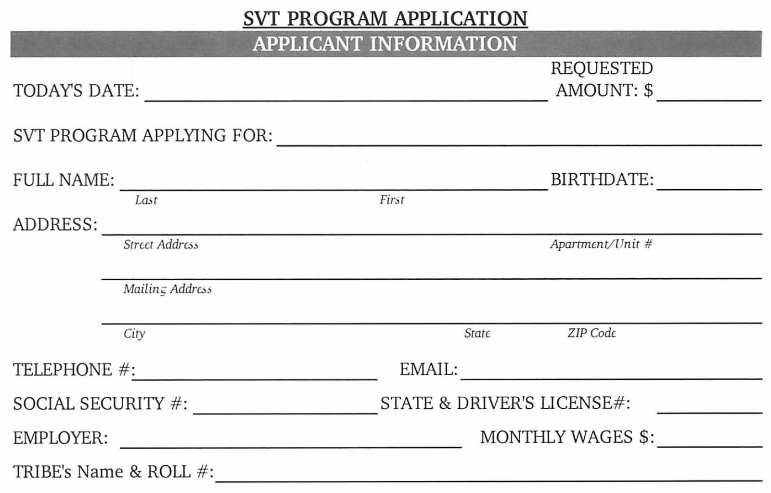
APPLICATION CHECKLIST
Please Provide All Information Below
Remember applications will NOT be started until ALL Information is provided.
- Application form - completely filled out and signed.
- Past year signed income tax form that was submitted to IRS. Or letter from the IRS, stating that you didn’t have to file for the last year.
- Proof of income for entire household for last 6 months. Pay stubs, Pensions, Social Security, Disability Payments, VA payments, ATAP-AFDC-FS-AAP printout, Unemployment Benefits payment stubs, Child Support, Alimony.
- CIB- Certification of Indian Blood (issued by the Bureau of Indian Affairs).
- Picture ID, Driver’s License or Passport.
- Original Social Security Cards for Applicant. Social Security cards for all children and all household members age 6 and above.
- Birth certificates for each child.
- If Disabled- Proof of Disability from Doctor or other legal source stating disability.
- Any Native Dividends received monthly, semiannually, or yearly.
- Any other payments received monthly, semiannually, or yearly.
- Signed letter from landlord stating amount of rent and security deposit required.
Please remember, if information is not brought with you it will only delay the approval process.
If you have questions or if you need to make an appointment, please call Honeybee at (907) 435-3260

4

Household members: Head of Household
Name: Birthdate
Name: Birthdate
Name Birthdate

DESCRIPTION OF WHY YOU NEED RENTAL ASSISTANCE:

ITEMIZATION OF RENTAL ASSISTANCE REQUIRED:

Security DEPOSIT: 1st month's RENT: Electric DEPOSIT: Phone DEPOSIT:
TOTAL ASSISTANCE REQUESTED:

APPLICANT CERTIFICATION

I have read and supplied the information in this application and understand that providing false information will disqualify me and can result in legal action.

I hereby certify that all information made on or in connection with this application is true and complete to the best of my knowledge. I understand that if I deliberately enter false information on this form, I may receive a $10,000 fine, imprisonment for not more than five years or both. I also understand that any misrepresentation or concealment of material fact will be sufficient grounds
for rejection of my application, removal from any eligibility list, or suspension from any SVT program participation and services.

Applicant Signature Date

SVT Housing Program Coordinator's Signature DATE Rec'd SVT President/CEO's Signature DATE approved
5

INCOME SOURCES
  - Total amount received by each household member for each type of income.
  - Verification must be provided before your application is approved.

TYPE of Income Received | 30 Day Amount | 12 Month Amount
Employment Income
Unemployment Benefits
Retirement/Disability Benefits
SSA Social Security Income
SSI Supplemental Security Income
TAN / ATAP
General Assistance / APA
Child Support
Food Stamps Received
Alaska Permanent Fund
Native Corporation Dividends
VA Payments
Other
TOTALS:

MONTHLY EXPENSES
  - Please fill in average monthly amounts

Household Expense | Amount |  | Miscellaneous Expenses | Amount
House Payment/Rent |  |  | Car Payment
Electricity |  |  | Car Insurance
Heating |  |  | Groceries
Phone (Base Charge) |  |  | Child Care
Home Insurance |  |  | Other
Other |  |  | Other
Other
TOTALS:

HAVE YOU PREVIOUSLY RECEIVED ASSISTANCE FROM SELDOVIA VILLAGE TRIBE? YES NO
IF YES, WHAT TYPE OF ASSISTANCE AND WHEN?

6

THINGS YOU SHOULD KNOW
The Seldovia Village Tribe Housing Program is funded through the U.S. Department of Housing and Urban Development (HUD).
PURPOSE
This document intends to inform you that there is certain information you must provide when applying for assisted housing. There are penalties that apply if you knowingly omit information and/or give false information.
IMPORTANT! Don’t risk your chances for Federally assisted housing by providing false, incomplete, or inaccurate information on your application and recertification forms.
PENALTIES FOR COMMITTING FRAUD
The United States Department of Housing and Urban Development (HUD) places a high priority on preventing fraud. If your application or recertification forms contain false or incomplete information, you may be:
- Evicted from your apartment or house
- Required to repay all assistance you received
- Fined up to $10,000.00
- Imprisoned for up or 5 years; and/or
- Prohibited from receiving future assistance.
Your State and local governments may have other laws and penalties as well.
ASKING QUESTIONS
When you sit down with the person who fills out your application, you should know what is expected of you. If you do not understand something, say so. That person can answer your question or find out what the answer is.
COMPLETING THE APPLICATION
When you give your answers to application questions, you must include the following information:
INCOME
- All sources of money you and any “adult” member of the family receive (wages, welfare
payments, alimony, social security, pensions, etc.).
- Any money you receive on behalf of your children (child support, social security for children, etc.).
- Income from assets (interest from a savings account, credit union, or certificate of deposit, dividends from stocks, AK Perm Dividend, etc.).
- Earnings from a second job or part time job.
- Any anticipated income (such as a bonus or pay raise you expect to receive).
FAMILY/HOUSEHOLD MEMBERS
- The names of all of the people (adults and children) who will actually be living with you whether or not they are related to you.
7

SIGNING THE APPLICATION
- Do not sign any form unless you have read it, understand it, and are sure everything is complete and accurate.
- When you sign the application and certification forms, you are claiming that they are complete to the best of your knowledge and belief. You are committing fraud if you sign a form knowing that it contains false or misleading information.
- Information you give on your application will be verified. In addition, HUD may do computer matches of the income you report with various Federal, State, or private agencies to verify that it is correct.
ASKING QUESTIONS
When you sit down with the person who fills out your application, you should know what is expected of you. If you do not understand something, say so. That person can answer your question or find out what the answer is.
RECERTIFICATIONS
Some programs require that you report any changes in income or family/household composition immediately. The Housing Coordinator will advise you if this applies to you. You must report changes on forms that will be provided to you.
These changes may include:
- All income changes, such as pay increases or benefits, change of job, loss of job, loss of benefits, etc. for all adult family/household members.
- Any family/household member who has moved in or out.
You should be aware of the following fraud schemes:
- Do not pay any money to file an application.
- Do not pay any money to move up on the waiting list.
- Do not pay for anything not covered by your lease.
- Get a receipt for the money you pay.
- Get a written explanation if you are required to pay any money other than rent (such as maintenance charges, etc.).
REPORTING ABUSE
If you are aware of anyone who has falsified an application, or if anyone tries to persuade you to make false statements, report them to the manager of your project. If you cannot report to the manager, call the local HUD office or the HUD hotline at (202) 472-4200. This is not a toll free number. You can also write to the HUD Hotline, Room 8254, 451 Seventh Street, SW, Washington, D.C. 20410.

I have read and understand this bulletin:

Page 2 of 2

8
Applicant Signature | Date

CLIENT RIGHTS – RESPONSIBILITIES & GRIEVANCE PROCEDURES

THE CLIENT HAS A RIGHT TO…
- Be treated with respect.
- Be treated without regard to race, color, creed, national origin, religion, sex, sexual preference or age.
- Be treated without regard to disability unless assistance being provided to individual will be hazardous to the individual.
- Have all personal information treated in a confidential manner.
- Review his/her file with appropriate staff present.
- Be fully informed regarding any and all fees associated with his/her services received from SVT.
THE CLIENT HAS THE RESPONSIBILITY TO…
- Treat SVT staff with respect.
- Be as accurate and complete as possible when providing information to SVT.
- To carry out SVT program rules and regulations related to the program he/she is applying for.
- Actively participate in the decision making process and perform those activities made during that process regarding any services received from SVT.
- Inform SVT staff of any changes in address, income, household size, etc.
CLIENT GRIEVANCE PROCEDURE
A procedure has been established and maintained by the Seldovia Village Tribe Housing Office to assist clients in resolving any complaints or grievances arising from a real or perceived violation of client rights.
No specific form is necessary to file a grievance, however a grievance must be in writing. You must clearly state the problem(s) by detailing the action taken or not taken by SVT staff and outline possible solutions and / or resolutions.
An earnest effort will be made by SVT staff to resolve problems encountered during all stages of program participation. The following steps outline the recommended procedure for attempting prompt resolutions to complaints/grievances regarding the service components of the Seldovia Village Tribe Housing Program:
- Submit a complaint in writing to the SVT Housing Coordinator. An informal meeting will be scheduled to discuss the complaint. If the complaint cannot be resolved informally, the Housing Coordinator shall, within 10 days after the receipt of the complaint, issue a written decision and inform the opportunity to further appeal the matter outlined in Step 2 below.
- If unsatisfied with the written decision by the Housing Coordinator, submit an appeal, in writing to the Seldovia Tribal Council, P.O. Drawer L, Seldovia, AK 99663. A hearing will be scheduled within 30 days of receipt of the appeal. The Chief Executive Officer will issue a written response within 10 days of the hearing with the Seldovia Tribal Council.

9

Seldovia Village Tribe ***** Housing Program Coordinator, Honeybee Nordenson ***** 907-435-3260

FY2024 NAHASDA INCOME LIMITS FOR ALASKA

Alaska Median Family Income $106,900 [four people]

Effective 07/07/2023
You must be at or UNDER the 80% Median Income to qualify for this Program Homeowners Assistance Fund is 150% Median 2022 Income
80%

AK Median
HAF limit

1-Person Household: | $74,850 | $59,850 | $103,350
2-Person Household: | $85,500 | $68,400 | $118,100
3-Person Household: | $96,200 | $77,000 | $132,850
4-Person Household: | $106,900 | $85,500 | $147,600
5-Person Household: | $115,450 | $92,350 | $159.450
6-Person Household: | $124,000 | $99,200 | $171,250
7-Person Household: | $132,550 | $106,050 | $183.050
8-Person Household: | $141,100 | $112,900 | $194,850
SVT Housing Programs
Housing Down Payment Assistance
Housing Weatherization/Modernization/Rehabilitation Assistance Tenant Rental Assistance
Housing Assistance for College / Vocational Training Housing Emergency Assistance

/Users/hnordenson/incomeguidelines/FY2024AKIncomeLimits80andHAF 28July2023

RELEASE OF INFORMATION

I, , hereby authorize the release of any information concerning me, to the Seldovia Village Tribe Housing Office, located at 206 Main Street, PO Drawer L, Seldovia, AK 99663. The requested information shall be used solely in the administration of SVT programs, and a reproduction of the release is as valid as the original.

CONTACTS MAY INCLUDE, BUT NOT BE LIMITED TO:

- Public Assistance
- Department of Labor
- Social Security Administration
- Veterans Administration
- Division of Vocational Rehabilitation (DVR)
- Employers
- Native Corporations
- Child Support Enforcement Agency
- Bureau of Indian Affairs
- Private Individuals
- Alaska Permanent Dividend Fund
- Alaska Longevity Fund
- SVT Tribal Services
- Other (Please Name):

THIS AUTHORITY SHALL CONTINUE UNTIL REVOKED IN WRITING BY THE UNDERSIGNED.

Applicant Signature Date Social Security Number

